Bio: Short Version
Jeff Selingo has written about higher education for more than two and a half decades and is a New York Times bestselling author of three books. His latest book, Who Gets In & Why: A Year Inside College Admissions, was published in 2020 and was named among the 100 Notable Books of the year by the New York Times. A regular contributor to The Atlantic, New York Times, and Washington Post, Jeff is a special advisor to the president and professor of practice at Arizona State University. He also writes a bi-weekly newsletter on all things higher ed called Next, co-hosts the podcast, Future U., and is working on his next book about how we need to look at good colleges beyond the top of the rankings, which is due out in late 2025. He lives near Washington, DC with his family.

Bio: Long Version (suitable for editing)
Jeff Selingo is a New York Times bestselling author of three books on education and the job market. For more than twenty-five years, his in-depth reporting and storytelling have provided practical insight about the future of higher education and the workforce to university leaders, corporate executives, as well as students and parents.

Jeff has talked before scores of colleges, businesses, healthcare organizations, and financial services companies and helped leaders understand what’s next for education and how companies can better compete for talent, especially among today’s Gen Z. He has appeared at the Milken Global Institute, Dartmouth College, LinkedIn, Ohio State University, Salesforce, Spain’s Bankinter Innovation Foundation, the Association of Schools Advancing Health Professions, and Deloitte, as well as before the boards of Carnegie Mellon University, the Duke Endowment, and Amherst College, among others.

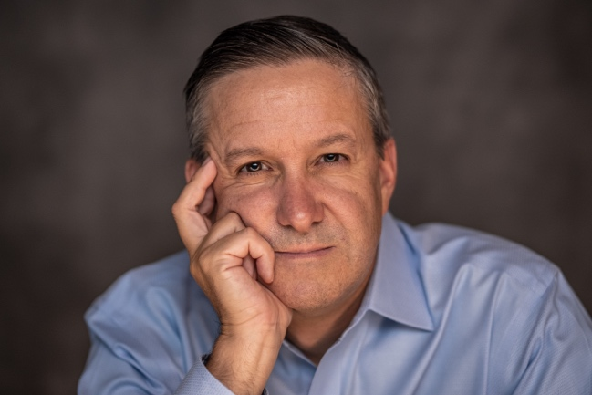
Jeff's latest book, Who Gets In & Why: A Year Inside College Admissions, was published in 2020 and was named among the 100 Notable Books of the year by the New York Times. It takes readers on a journey through the selection process from inside three admissions offices, revealing what really matters to the gatekeepers and how the ultimate decision is often based on a college’s priorities. He is currently working on his next book about how we need to look at good colleges beyond the top of the rankings, which is due out in late 2025.

As both an observer of higher education and an insider with an academic appointment at one of the largest universities in the country, Jeff occupies a unique position to explain the intersection between work, life, and learning. He writes regularly for The Atlantic, the Washington Post, the New York Times, and the Wall Street Journal.

His research focuses on the changing nature of work and its impact on education, paying for college, the student experience, and shifting expectations for what the public and employers want from colleges. He is co-host of the podcast, Future U., and writes a biweekly newsletter, Next.

Jeff is a special advisor to the president and professor of practice at Arizona State University, where he is the founding director of the Academy for Innovative Higher Education Leadership. He has also served as a visiting scholar at Georgia Tech’s Center for 21st Century Universities. In addition, Jeff regularly counsels universities and organizations on strategy.

Previously, Jeff was the top editor of the Chronicle of Higher Education, where he worked for sixteen years in a variety of reporting and editing roles. His work has been honored by the Education Writers Association, Society of Professional Journalists, and the Associated Press.

He received a bachelor’s degree from Ithaca College and a master’s degree from the Johns Hopkins University. He is a member of the board of trustees at Ithaca College and the board of directors of the National Association of Independent Schools (NAIS). He lives with his wife and two daughters near Washington, D.C.

